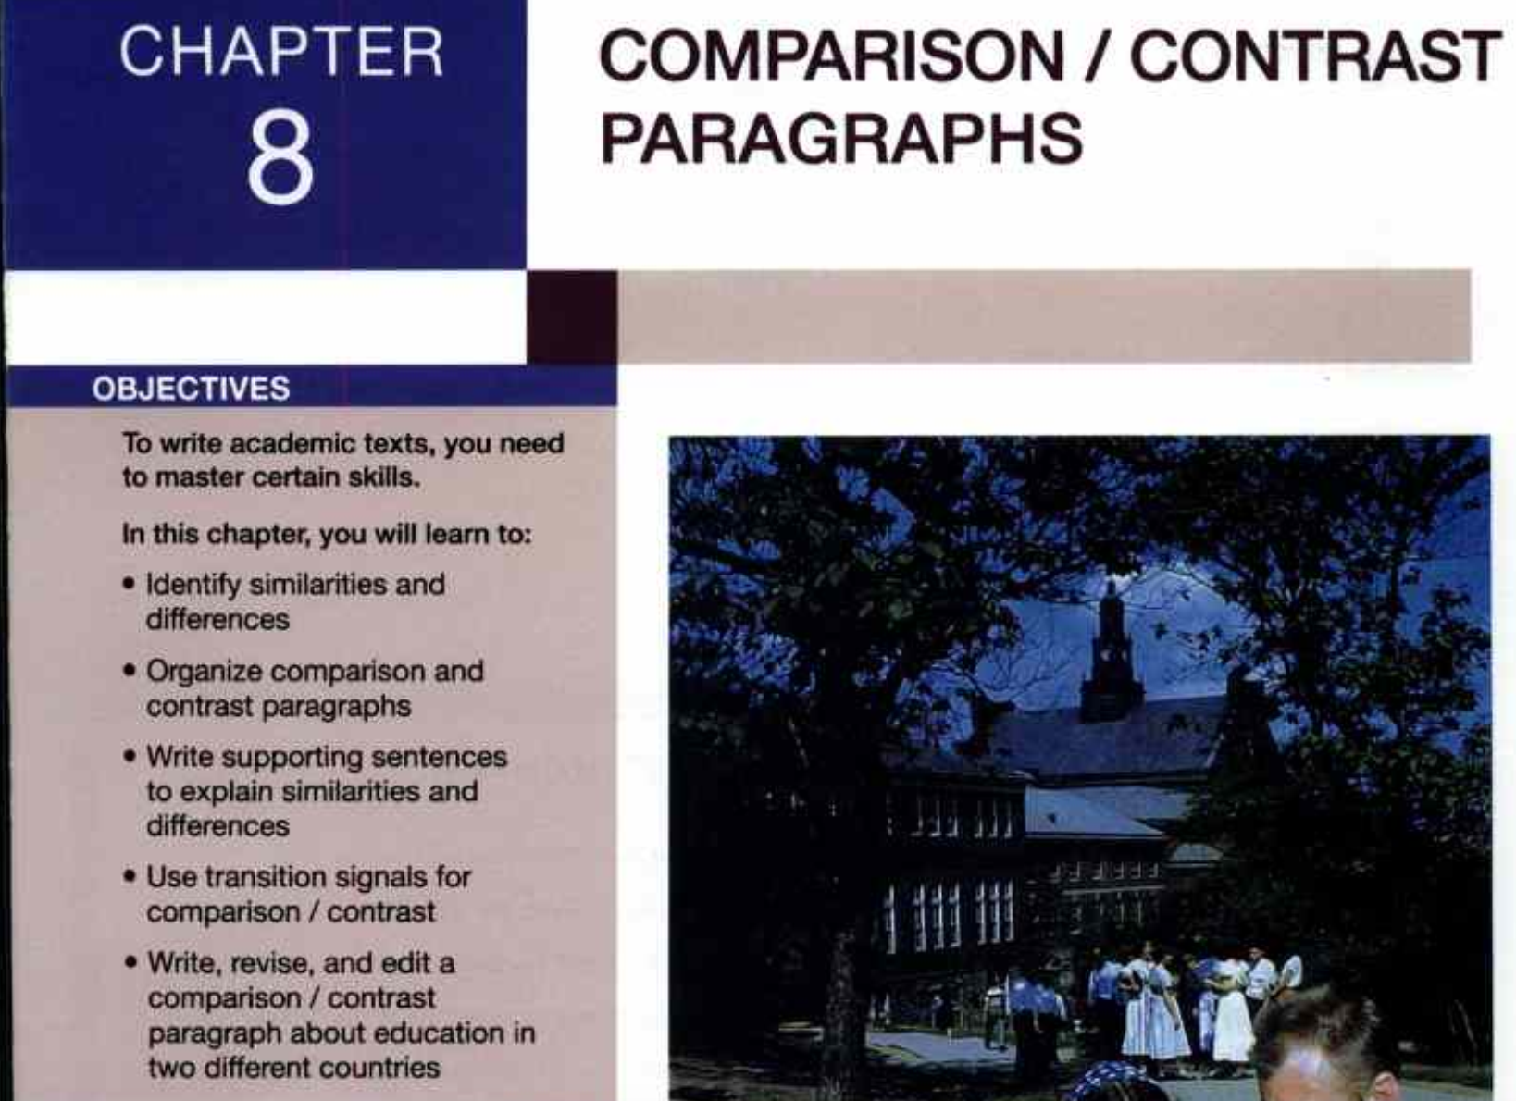
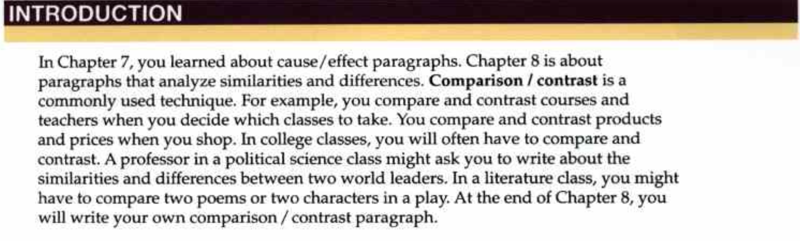
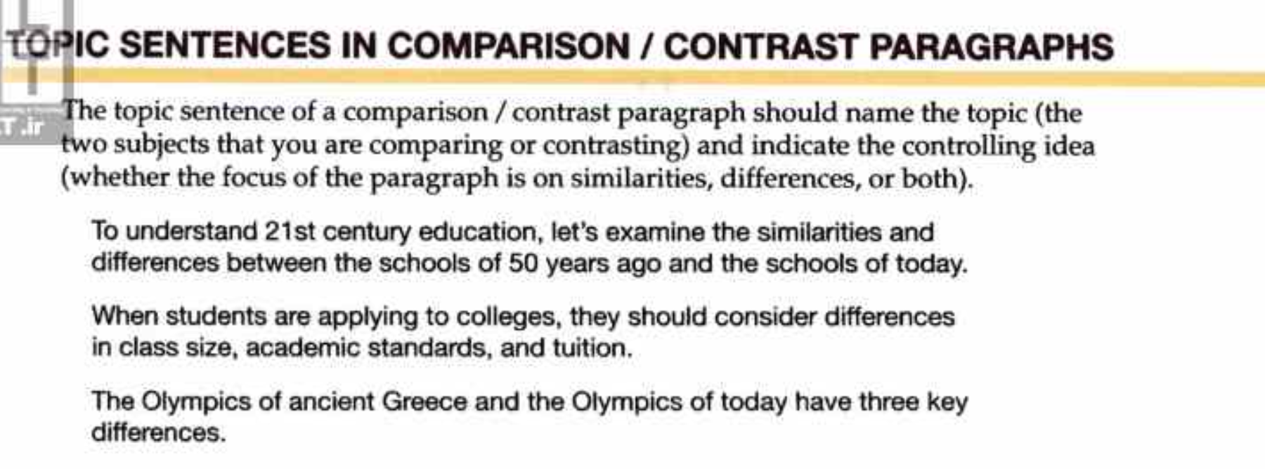
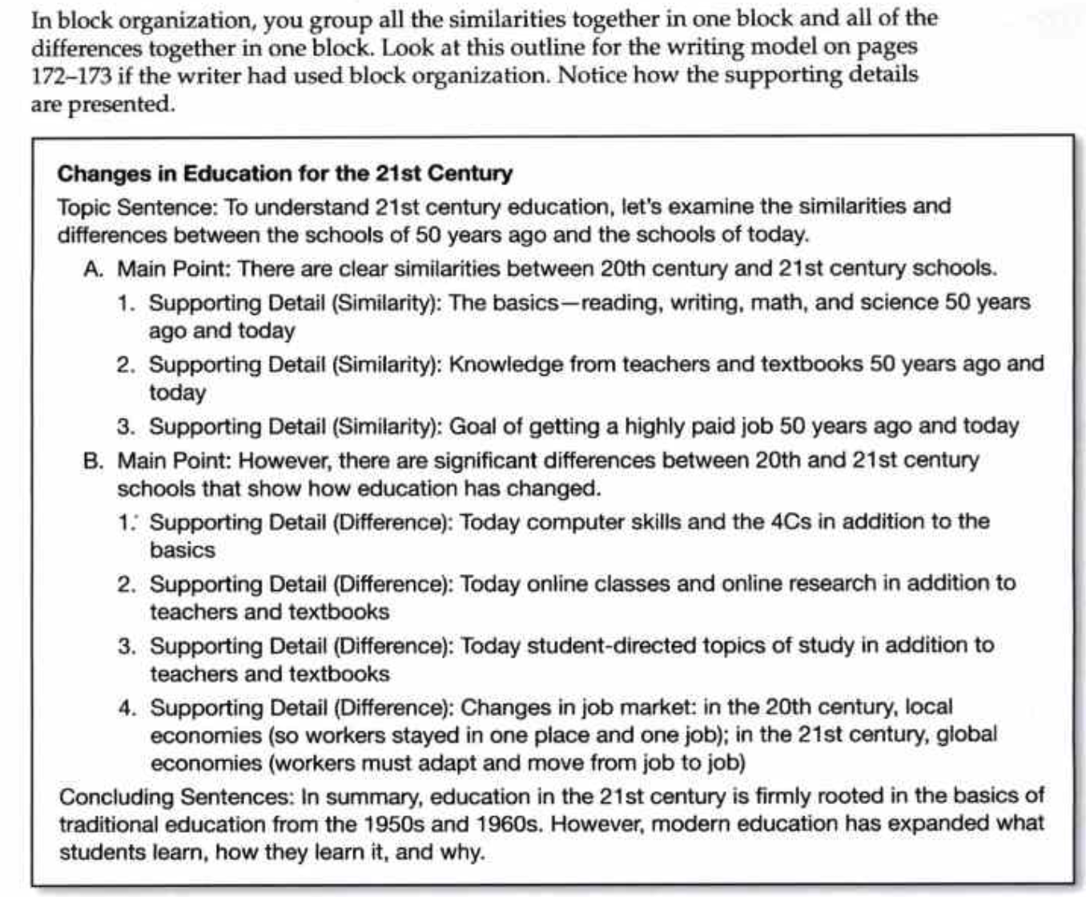

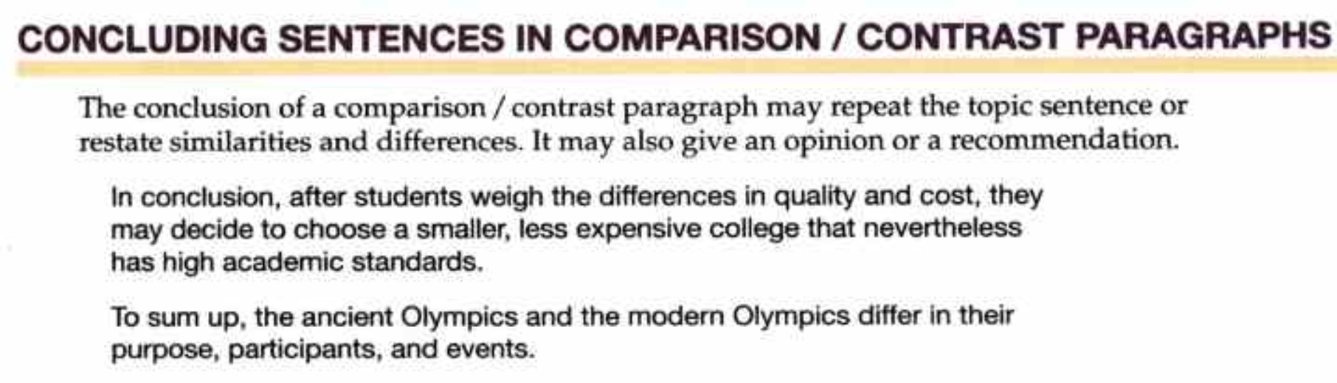
FOCUS ON DIFFERENCES PARAGRAPH
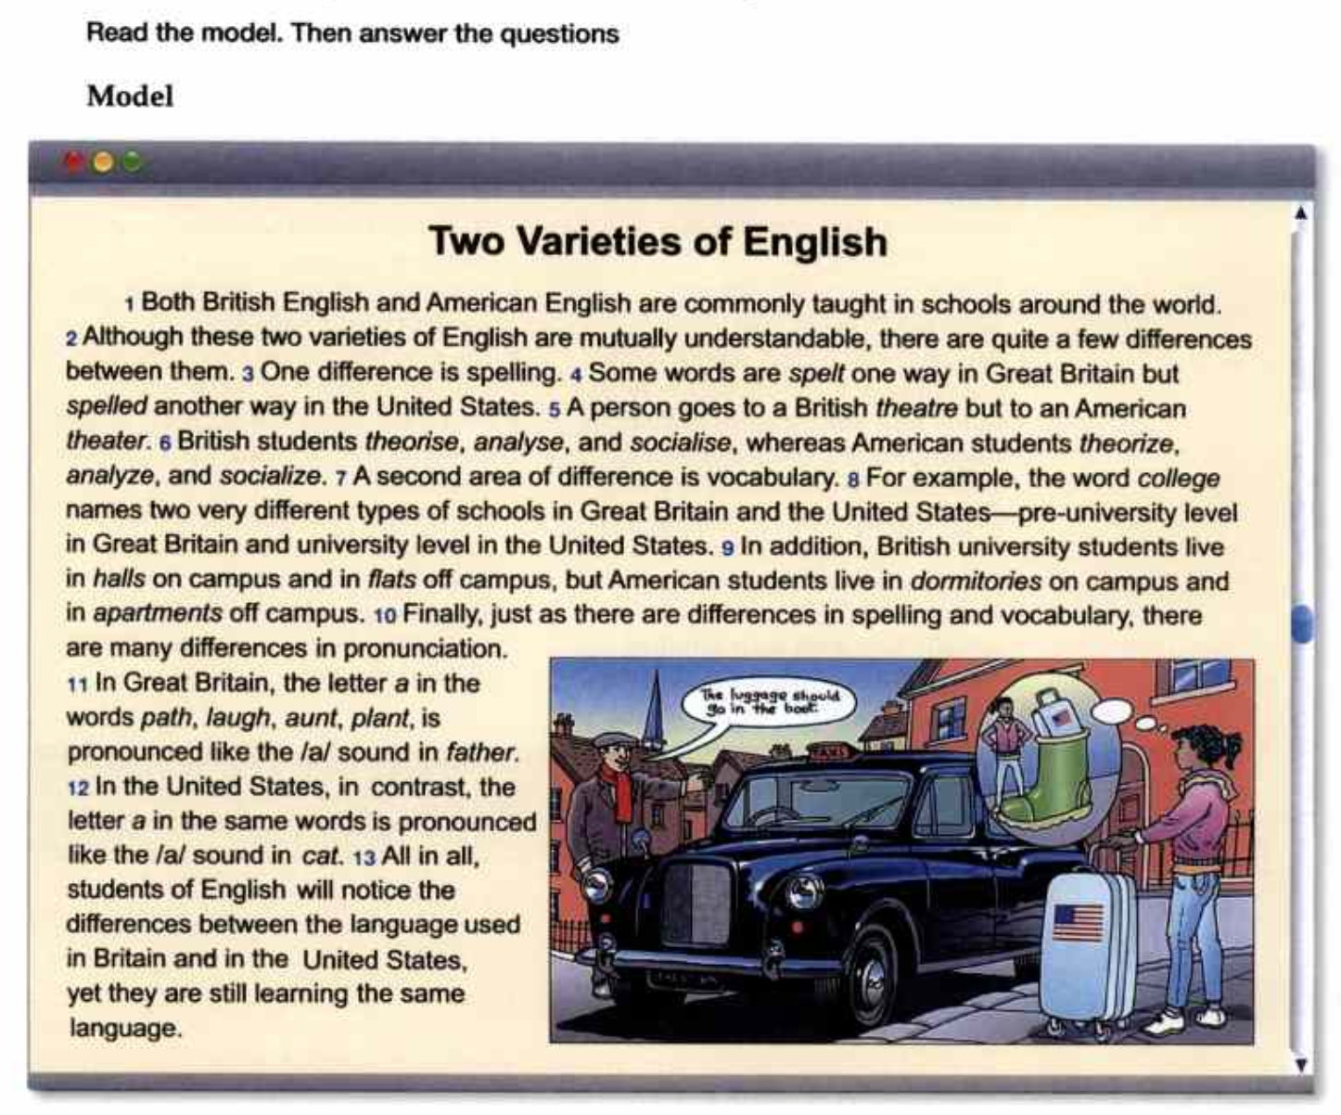

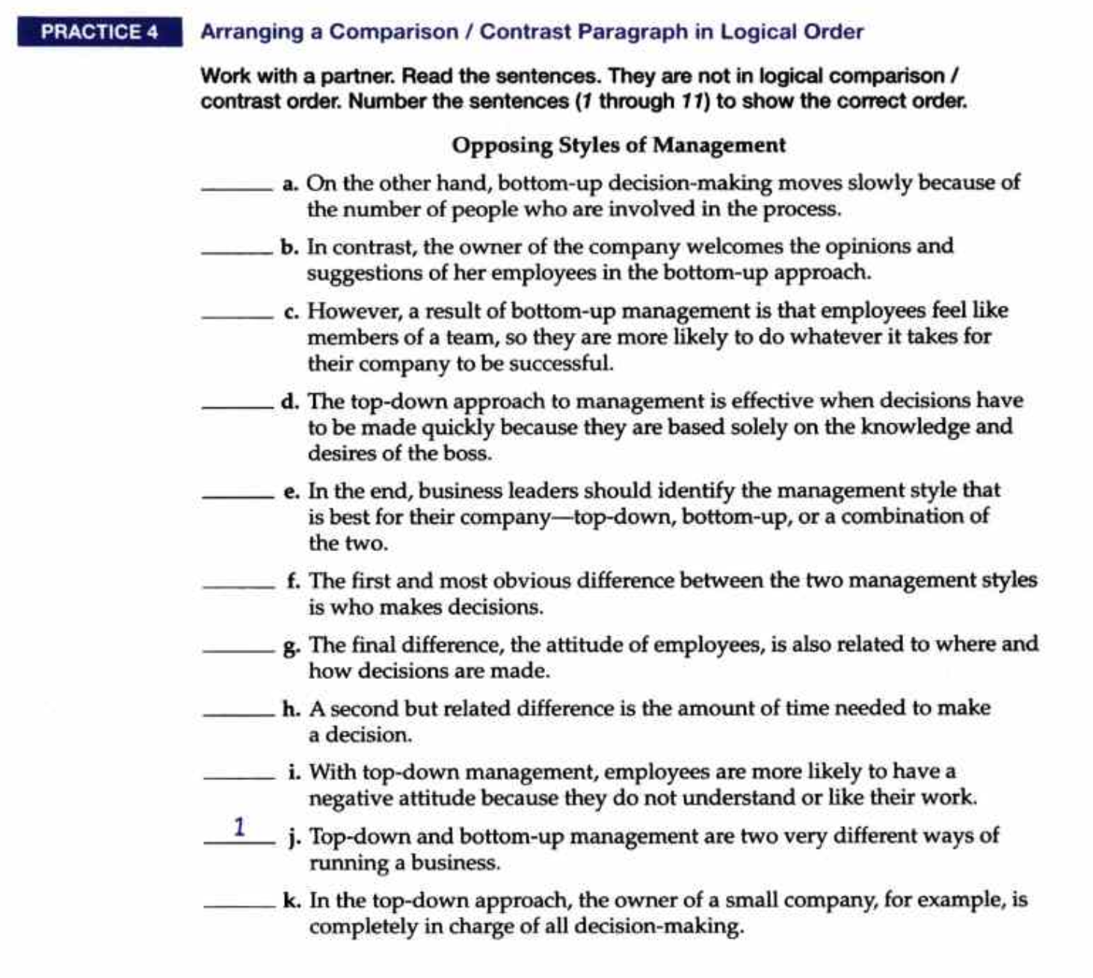
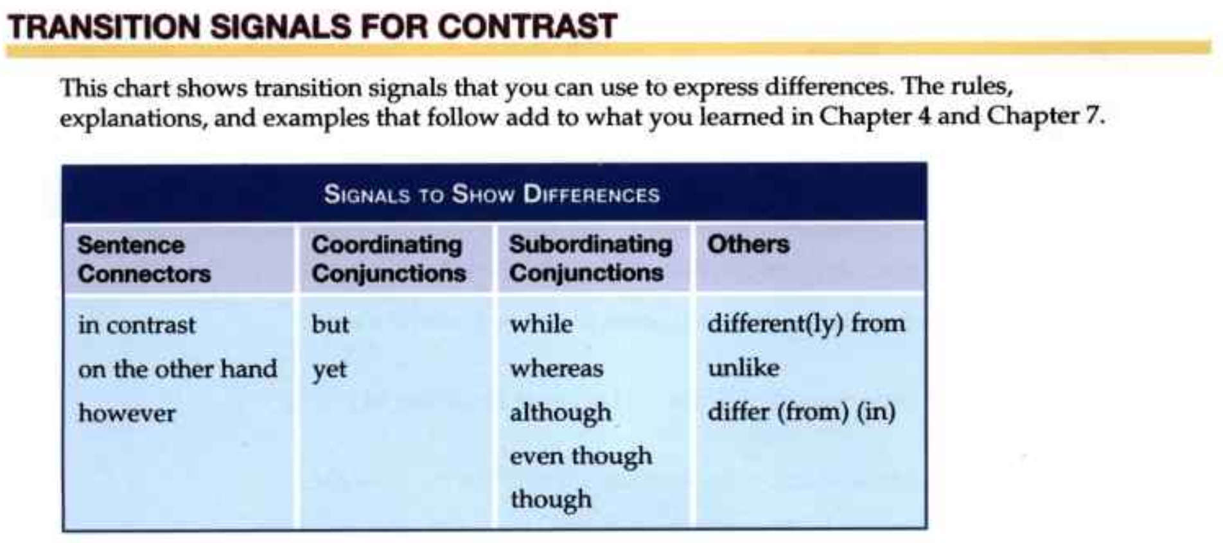
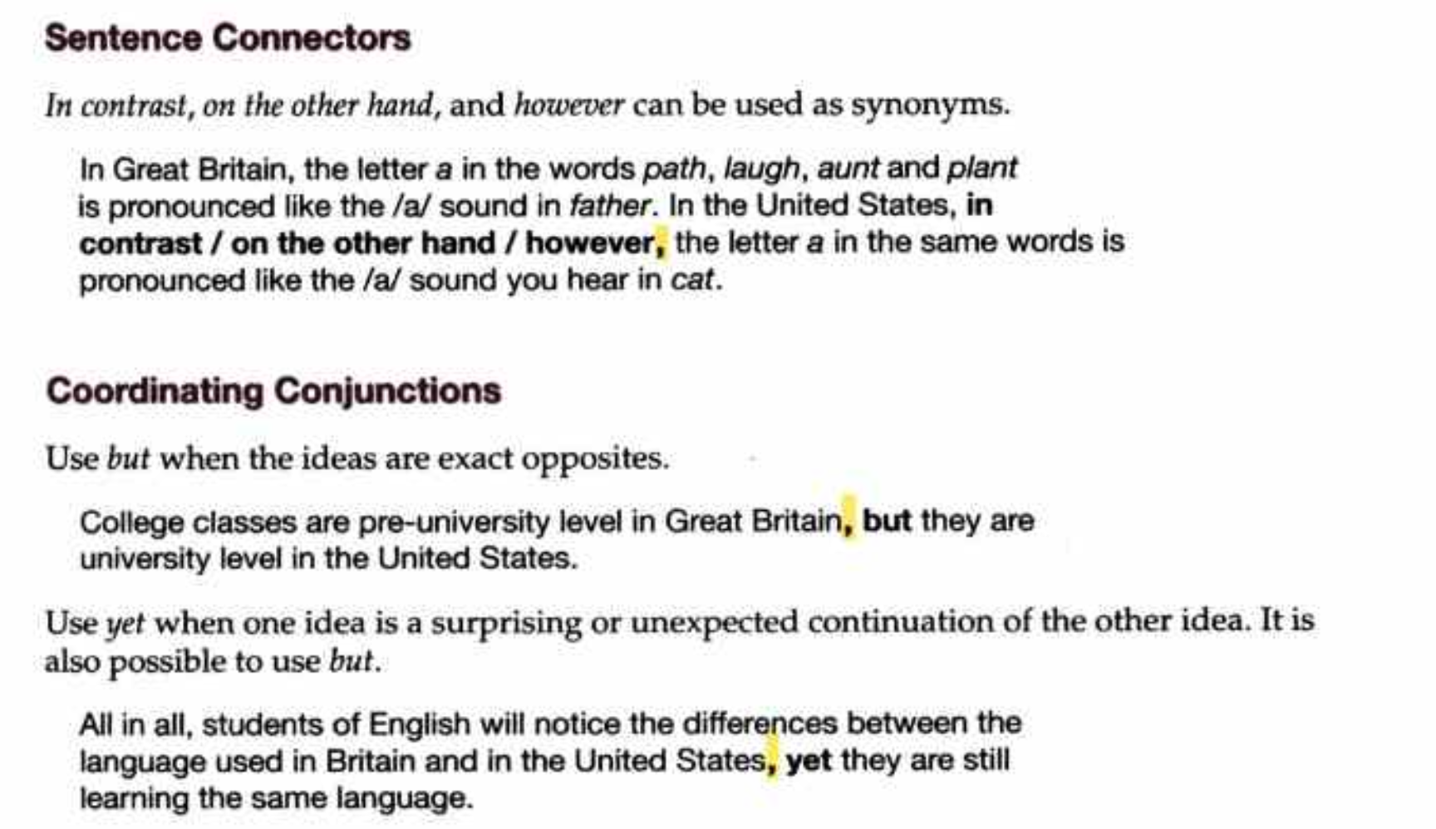
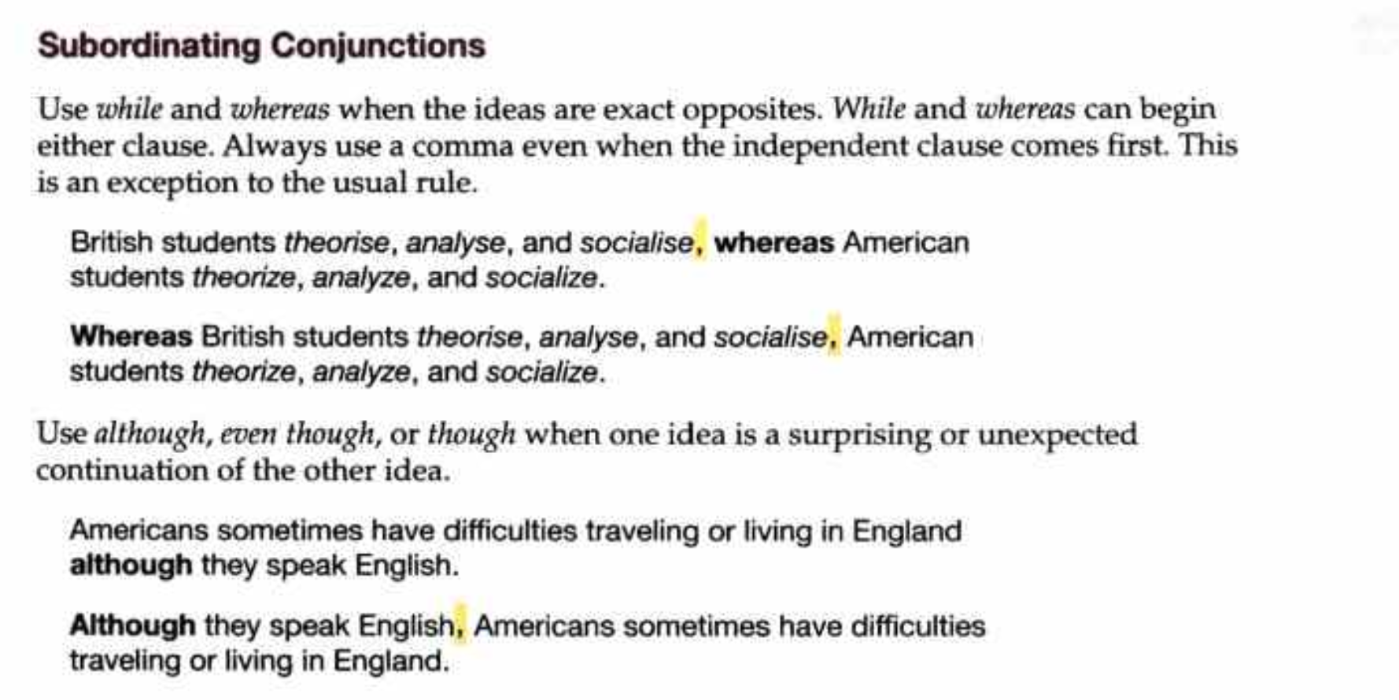
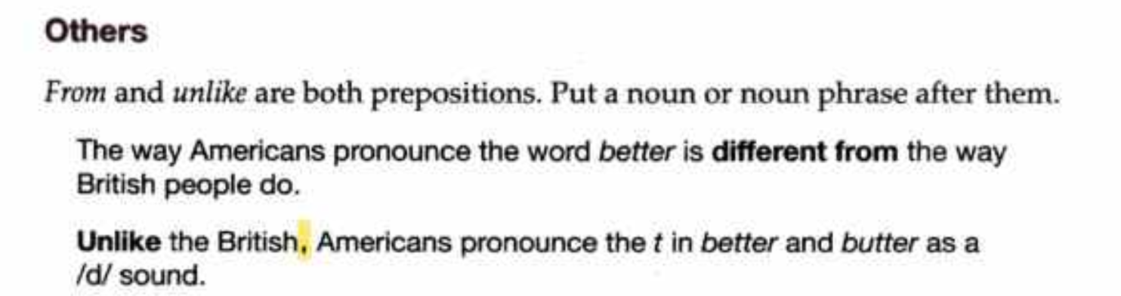
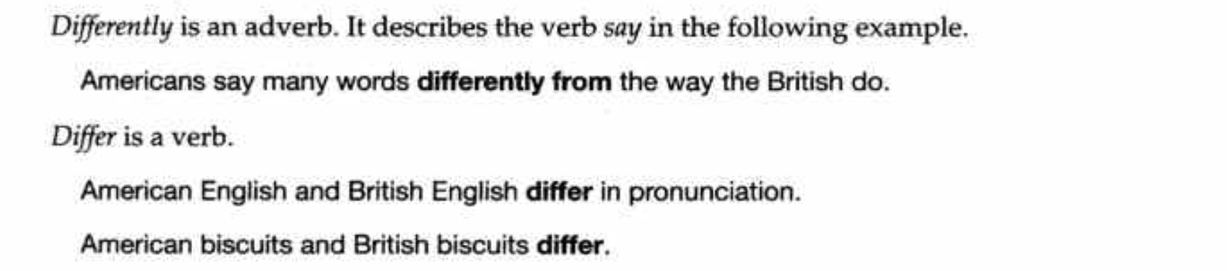
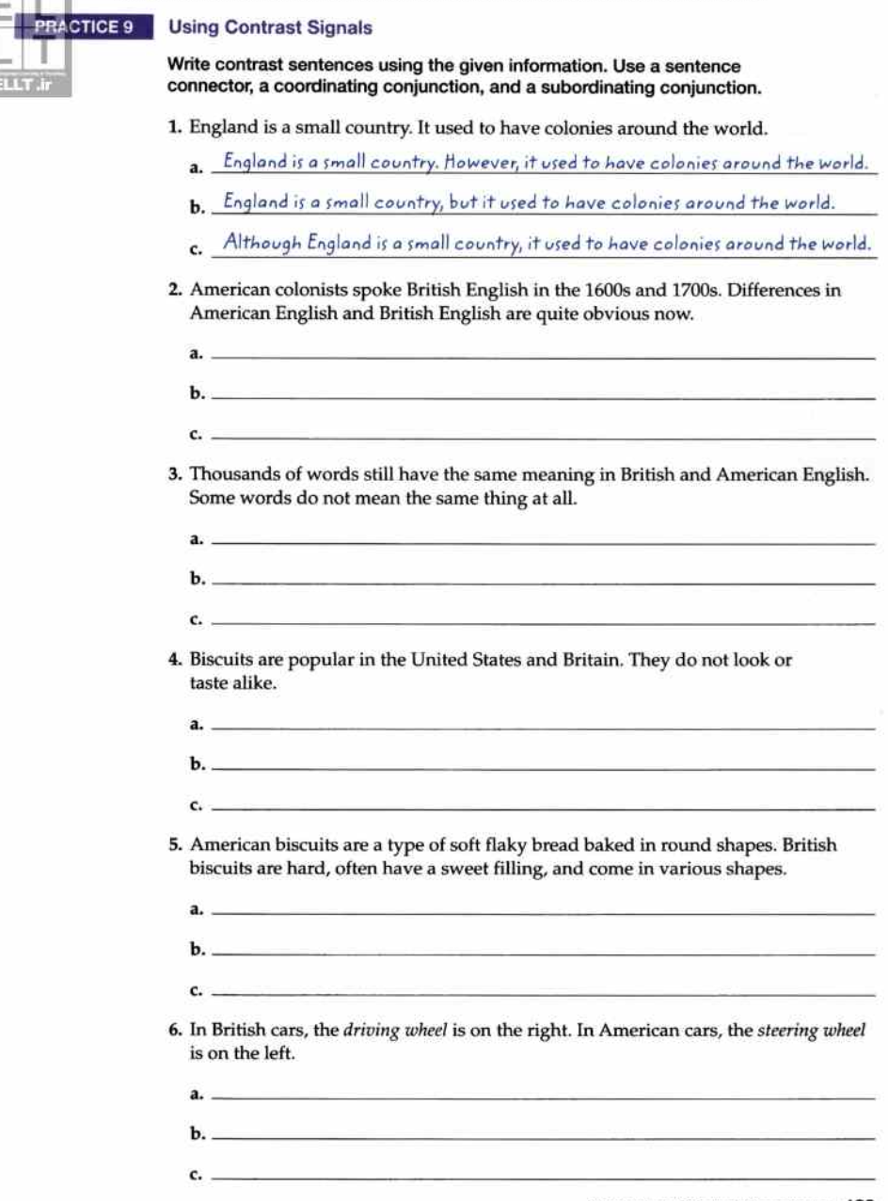
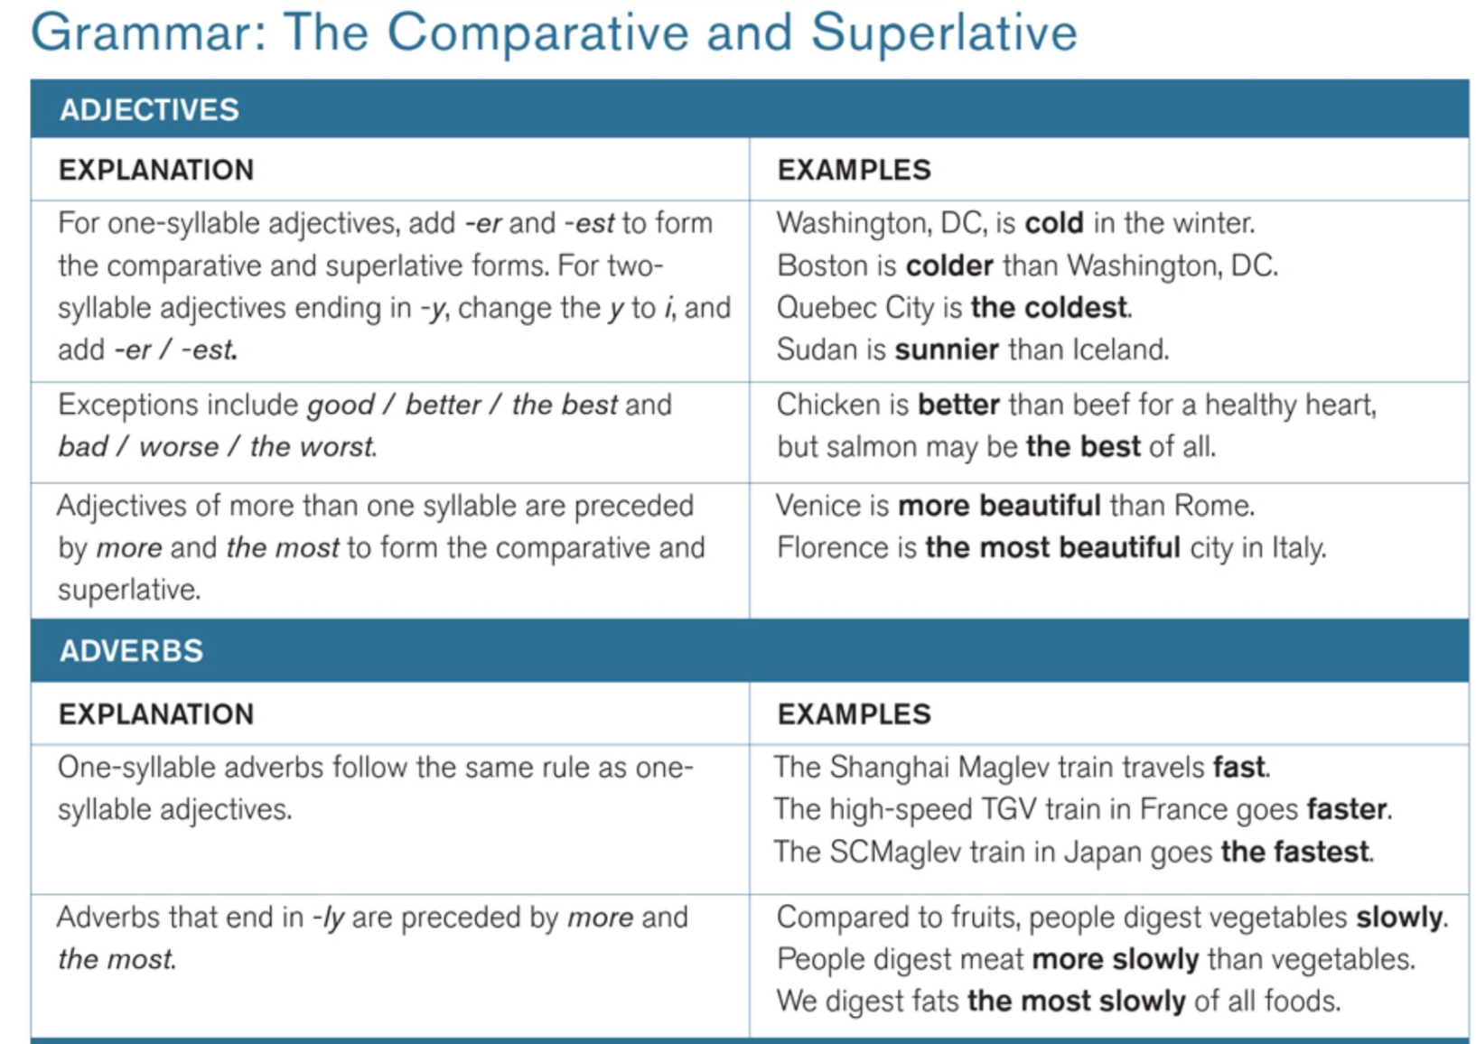
Note: You can use “compared to” instead of “than” to sound more formal.
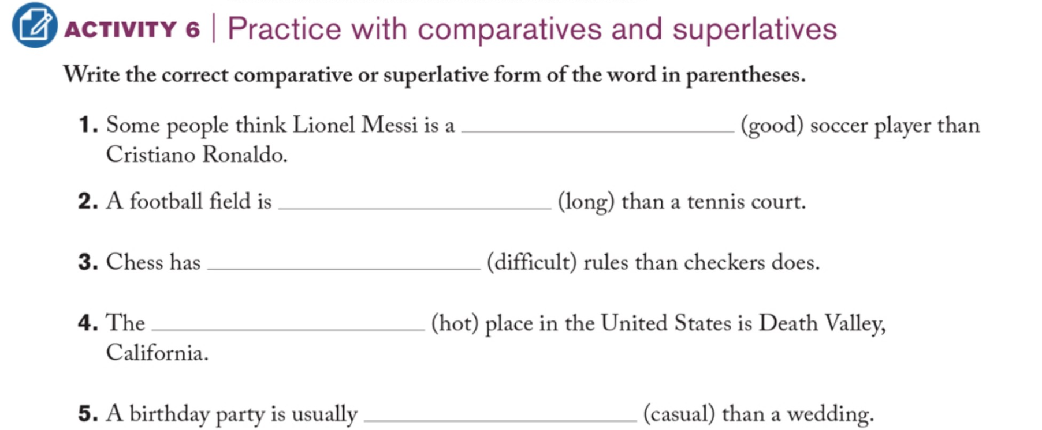

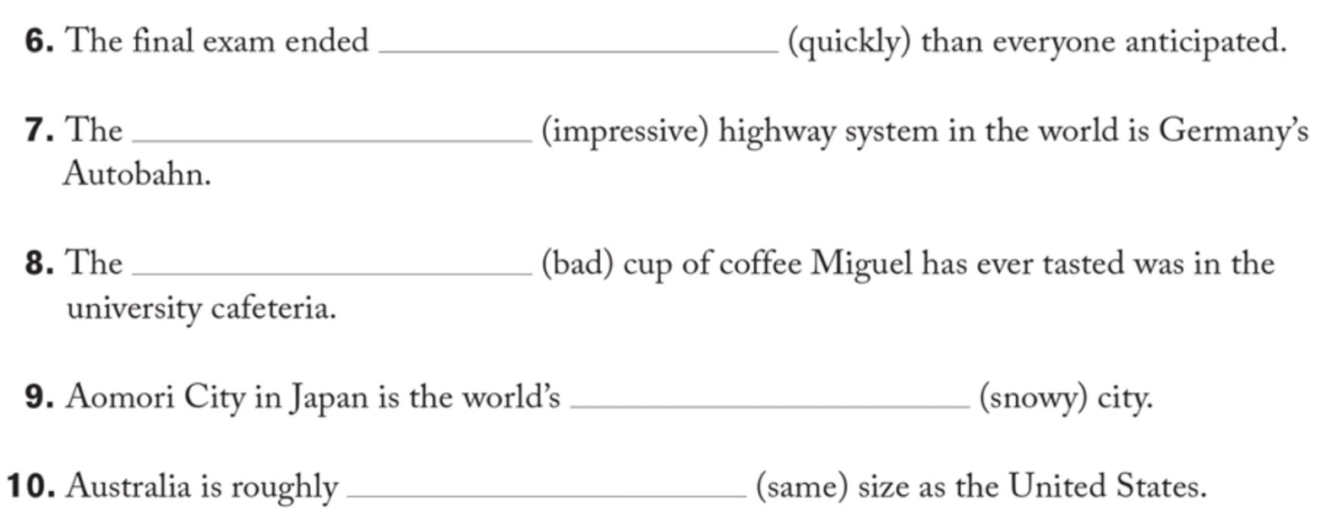
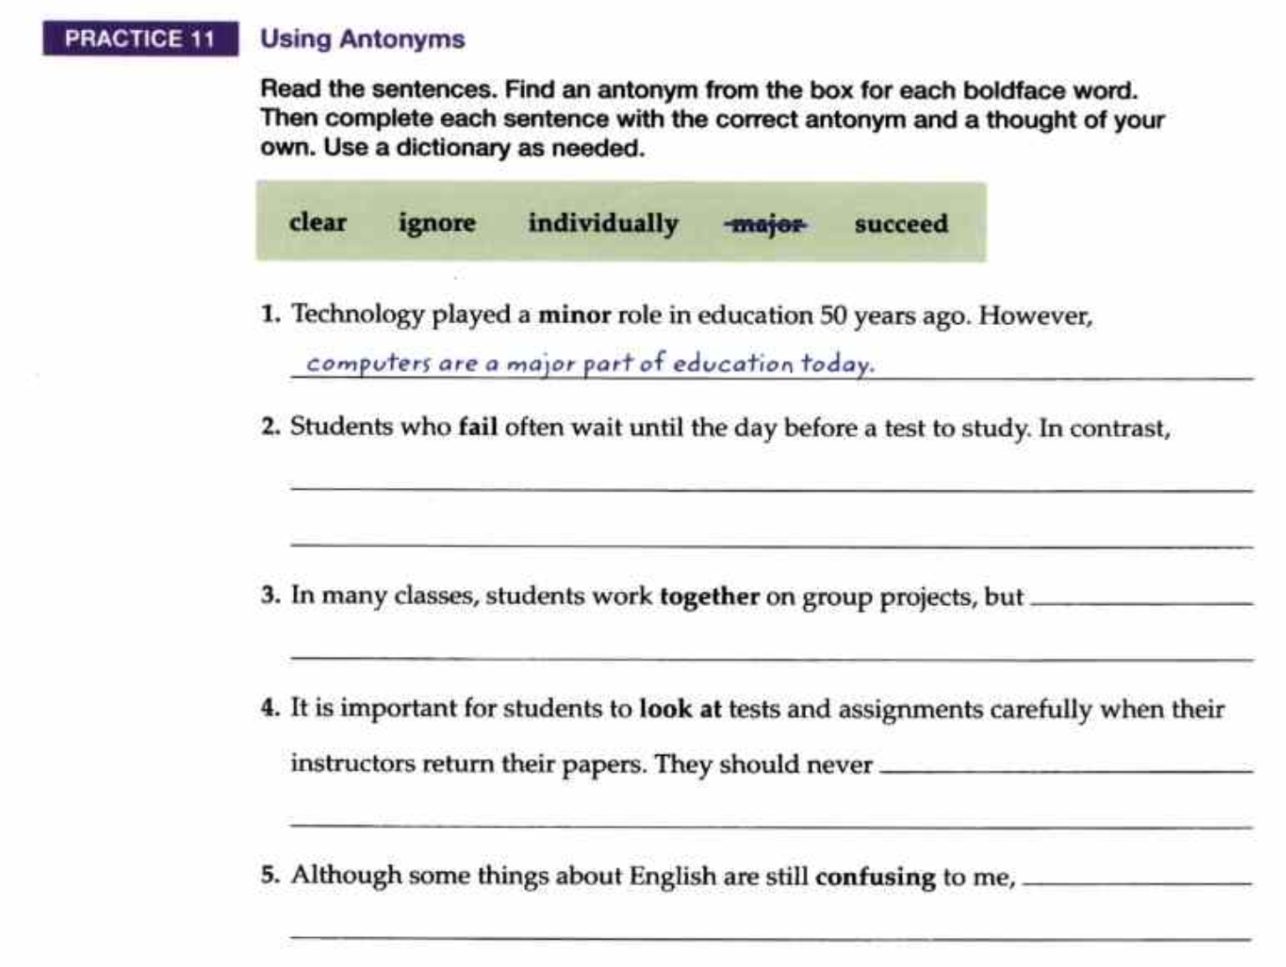

WRITING PRACTICE

Write a paragraph to analyze the differences between working from home and working at the office

There are both similarities and differences between [A] and [B], and each has its own advantages and disadvantages. This paragraph will first discuss the similarities between the two before moving on to their main differences.
To begin with, [A] and [B] are similar in several ways. One important similarity is their. ..........To be specific, [A].....Similarly, B........ In addition, [A] and [B] are also alike in …………, which means that just like [A], which……………., B..................
However, despite these similarities, there are also some clear differences between the two. To begin with, [A] is generally different from [B] in [aspect 1]. [A]………, whereas [B] tends to be ………..As a result, …………….Another noticeable difference can be seen in [aspect 2]. While [A]………, [B]………..
In conclusion, although both [A] and [B] share some similarities, I believe that [A / B] is the better choice
because ……………….

